Over-estimation bias with DDPG and TD3 on LunarLander

- Methodology
In my notebook, I have put together four different models in order to study the effect of over-estimation bias on performance. I have started by training DDPG and TD3 models using the optimal hyperparameters specified by RL Baselines Zoo. Then, I altered these hyperparameters in a way that maximizes the likelihood that over-estimation bias will occur and trained other instances of DDPG and TD3 models. I increased the noise of the initial probability distribution over actions and the learning rate, and reduced the replay buffer size. This method will allow me to compare the performance of DDPG and TD3 while also being able to have a within-algorithm comparison where the optimal version of the algorithm can serve as a sort of control condition.
Models were trained for 200,000 timesteps and metrics were recorded every 1000 training timesteps. For each model, I produced a curve that shows the mean Q-value per training timestep to measure overestimation bias, and a learning curve (mean reward over 5 runs of the current policy per training timestep) to measure performance.
Ideally, for more thorough analysis, we would have liked to look at multiple instances of each model ran on different random seeds to be sure that results are generalizable (e.g. if I don’t find any over-estimation bias, to be sure that other instances also don’t encounter the problem), but the running time required given our computational resources was too large.

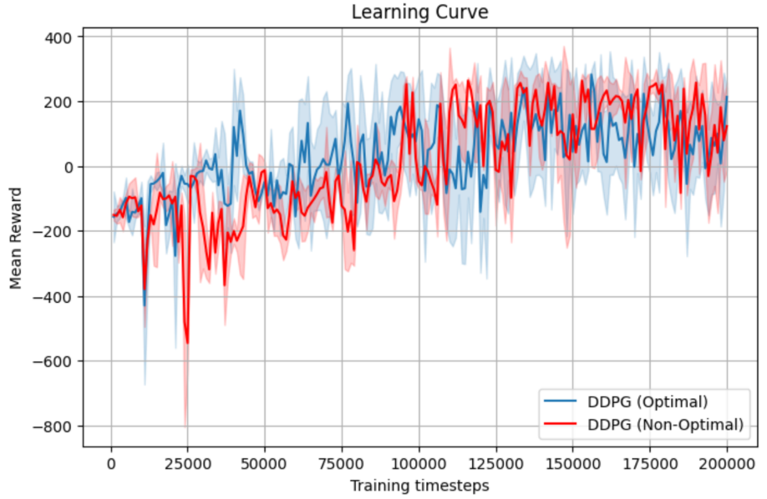
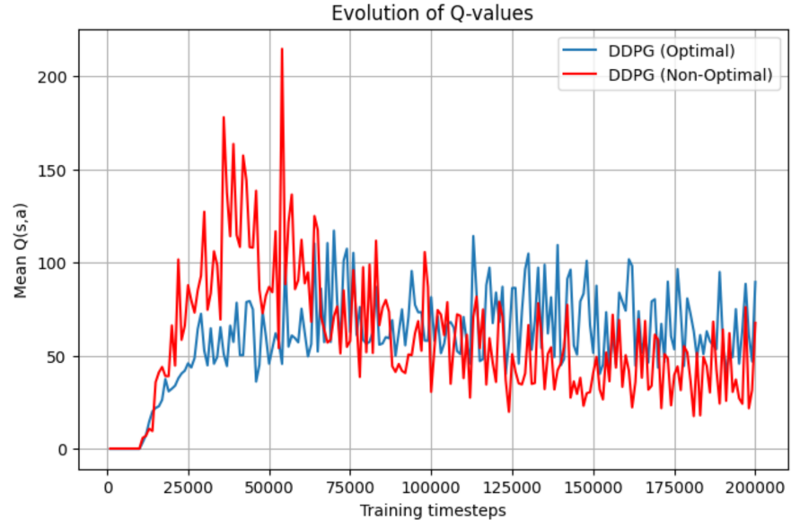
- DDPG Optimal vs. DDPG Non-Optimal
Figure 1: Evolution of mean Q-Value over training timesteps for Optimal and Non-Optimal DDPG. Peak in Non-Optimal DDPG mean Q-value indicated over-estimation bias.
Figure 2: Evolution of mean reward over training timesteps for Optimal and Non-Optimal DDPG. No particular differences can be seen.

In the within-algorithm comparison of DDPG, I can see a clear peak in the mean of the Q-values in the non-optimal version of the model compared to the optimal ‘control’ condition (Figure 1), which indicates an over-estimation of the q-values in a local part of the environment. Both learning curves follow a similar pattern (Figure 2) but the final reward values averaged over 5 runs of the final policy show a better performance for the optimal DDPG (107.7) compared to the Non-Optimal DDPG (78.9) (t(4)= 0.261, p-value= 0.8). Since p-value is too large, I don’t have enough evidence to strongly conclude that over-estimation has negatively impacted the model’s performance, so further testing and more sampling would be required to be able to make a strong conclusion. One-by-one changes in hyperparameter values can also be useful to be able to say that a difference in performance is due to over-estimation bias and not other effects of the changes in hyperparameters.

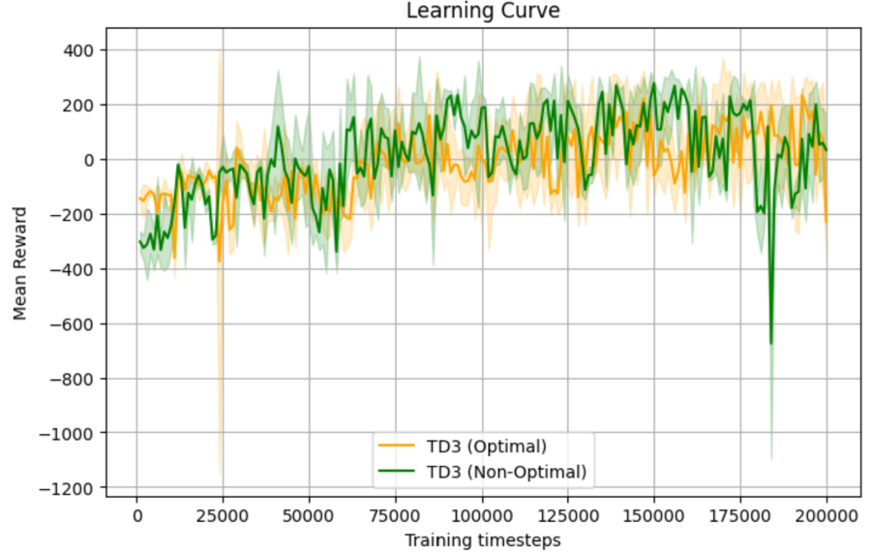
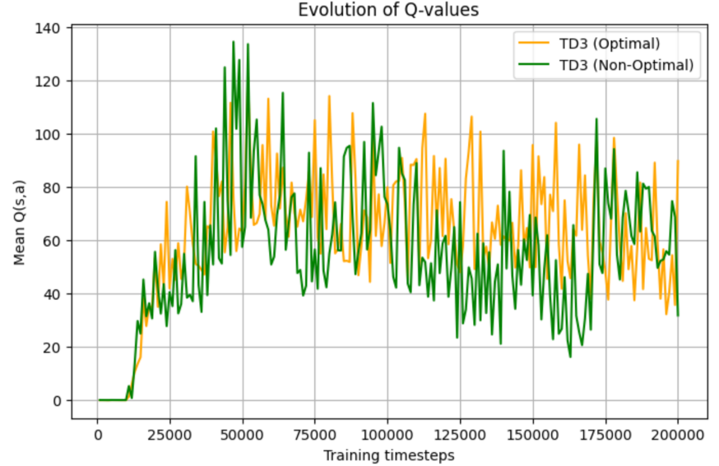
- TD3 Optimal vs. TD3 Non-Optimal
Figure 4: Evolution of mean reward over training timesteps for Optimal and Non-Optimal DDPG. No particular differences can be seen.

Figure 3: Evolution of mean Q-Value over training timesteps for Optimal and Non-Optimal TD3. Peak in Non-Optimal DDPG mean Q-value indicated over-estimation bias.

In the within-algorithm comparison of TD3, we see a similar pattern for both mean Q-values curves and both learning curves (Figures 3 & 4). That could be due to TD3’s more robust ability to avoid over-estimation bias by selecting the minimum of its two critics outputs for each update performed. The small peaks seen in the mean Q-value curves could thus be explained by an over-estimation bias only if both its critics run into over-estimation bias. The min operator would thus reduce the effect of the bias. Considering TD3 Optimal also has a small peak though, that scenario is unlikely, and the small peaks could be due to normal exploration instead.

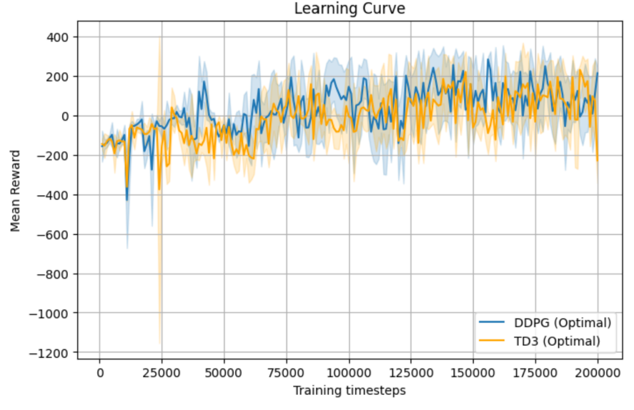
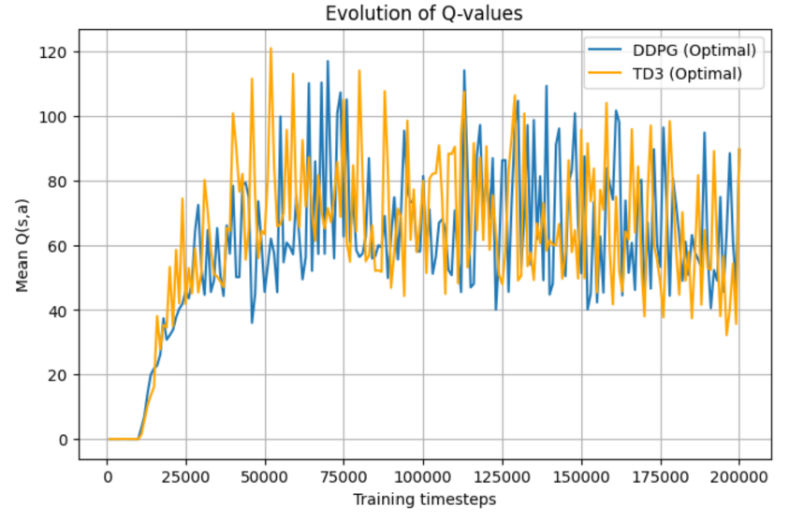
- DDPG vs. TD3: Optimal Hyperparameters
Figure 6: Evolution of mean reward over training timesteps for Optimal DDPG and TD3. Both models show typical learning patterns.

Figure 5: Evolution of mean Q-Value over training timesteps for Optimal DDPG and TD3. Both models have similar behavior with no over-estimation.

Using optimal parameters on DDPG and TD3, both models behave similarly. The mean Q-values curve doesn’t show any remarkable increases that could signal over-estimation during the training (Figure 5). Both learning curves follow similar patterns (Figure 6), they gradually increase but don’t converge, possibly due to insufficient training timesteps as the RL Baselines Zoo total timesteps variable was set to 300,000 but I had to reduce it to 200,000 for the run to complete in time for this project. Thus, no conclusions can be made by comparing these two models.

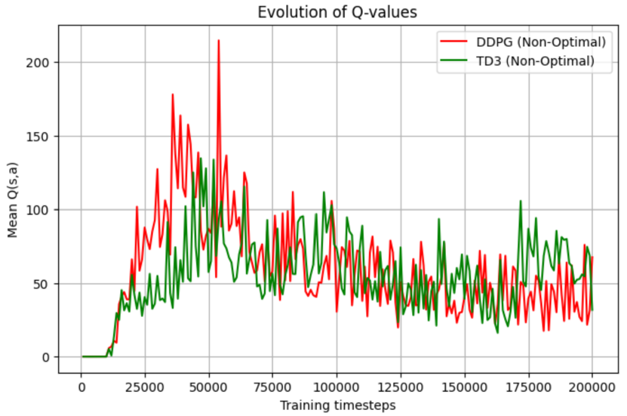
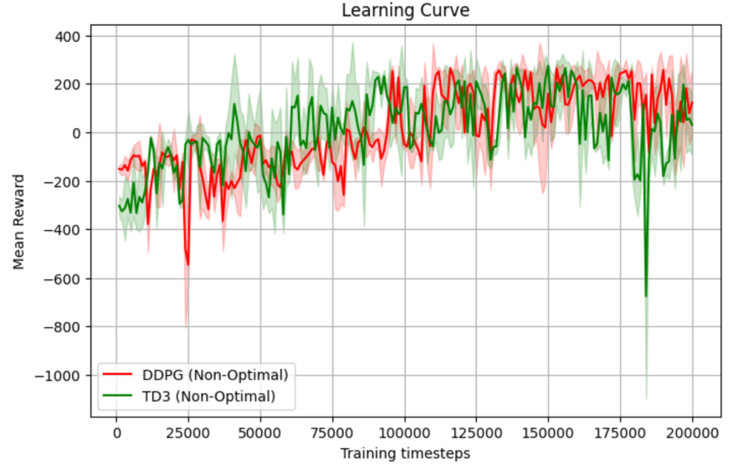
- DDPG vs. TD3: Non-Optimal Hyperparameters
Figure 7: Evolution of mean Q-Value over training timesteps for Non-Optimal DDPG and TD3. DDPG peak indicates over-estimation bias while TD3 has a smaller peak that might indicate faded over-estimation bias.
Figure 8: Evolution of mean reward over training timesteps for Optimal DDPG and TD3. Both models show similar patterns with some negative peaks.

Using non-optimal parameters on DDPG and TD3, as we said, we can see a clear peak due to over-estimation bias in DDPG, while TD3 shows a smaller peak that can only be explained by over-estimation bias in both of its critics (Figure 7). For performance, DDPG has a score of 78.8 and TD3 a score of 56.8, which don’t show a statistically significant difference (t(4)= 0.135, p= 0.89). So we again can’t make a definitive conclusion about the effect of over-estimation bias on performance, and the higher metric of performance for DDPG compared to TD3 hints towards a lack of effect of over-estimation bias on performance, at least given our specific environment and parameter definitions.

- Conclusion:
All in all, although non-optimal hyperparameters do amplify over-estimation bias, I see no statistically significant effect on performance of the model after training. Some researchers are even looking into overestimation bias having a potentially positive effect on performance depending on the environment the model is trained in. For instance, given the choice between an action a1 that corresponds to going to s1 which results in a random reward and another action a2 that corresponds to going to s2 which results in 0 reward, the agent may overestimate the value of choosing a1 due to occasional high random rewards, or it could underestimate it if initial random values of s1 are negative. In this case, overestimation thus leads the agent to choose the optimal sequence (2020, Pentaliotis).

Reference:
Pentaliotis, Andreas (2020). Investigating Overestimation Bias in Reinforcement Learning. Master's Thesis / Essay, Artificial Intelligence.

